|  |  |  |
| --- | --- | --- |
| **1091 Site Management Report** | | **November 22, 2018** |
|  | |  |
| ***Standard Operating Procedure*** |  | |

**Document Author:**

Name: Momodou (Mo) Keita Date: December 13, 2017

**Report Author:**

Name: Date:

**PURPOSE:**

The Centralization of site map management by the IT Team. This report will be used to display key site information required in the creation and maintenance of site in TMW. The Main focus will be Site maps and route maps.

Site maps are created and managed by the operation team in each division. Site maps are created after an inspection of the site is completed. Subsequent changes to the site are reported to the operation team, site maps are updated then sent to the support team.

The operations team in each division creates their own site maps, because of this, there is no central location in which all site maps are located. Site maps are also saved in different formats by different divisions.

|  |  |  |
| --- | --- | --- |
| **Region** | **Site map file format** | **Description** |
| Atlantic | .xls | MS Excel |
| Central | *.pdf & *.xls | PDF and MS Excel |
| Manitei | *.doc | MS Word |
| Seaboard West | *.jpeg | Image file |
| Wiebe | *.pdf | PDF |

The IT team will be responsible for managing the report. All Site maps will be moved to a centralized location (TMW)

The report will also display: the sites basic information including billing, delivery instructions, tank profiles, Load requirements for each site and all loading terminal information for the site including Master order and badge numbers.

**SECURITY:**

Security will be at the user level. The only user who will be using the report will be the operations, dispatch and HSE teams. Changes on the report can only be requested by member of the operations and HSE teams. Dispatch can only request changes to the badge number on the report

**DATA POPULATION & LOGIC:**

**Data population**

**All the data required for this report will be gathered from the TMW database.**

**Data Sources:**

|  |  |
| --- | --- |
| **Table** | **Description** |
| dbo.Company | Site/consignee information |
| dbo.City | Location Information |
| dbo.Labelfile | Code Definition Information |
| dbo.EXTRA_INFO_DATA | Addtitional Site Information |
| dbo.ps_blob_date | Object information/ Images |

**Report Description**

**Parameters**

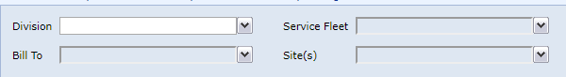

|  |  |
| --- | --- |
| **Parameter** | **Description** |
| Division(cmp_revtype1) | Operational Division of site / Terminal |
| Service Fleet | Fleet the site / terminal operates under |
| Bill To | TMW customer that pay's for completed orders. |
| site(s) | A list of sites filtered for(Division,Service Fleet & Bill To |

**Fields**

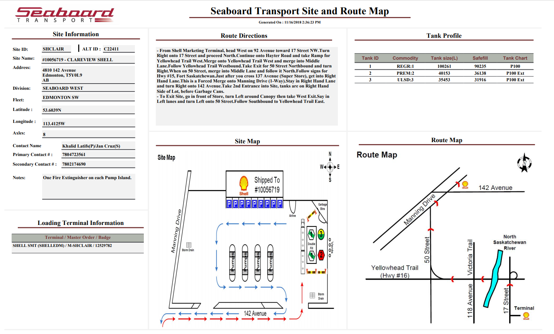

|  |  |  |  |
| --- | --- | --- | --- |
| **Field** | **Description** | **Source(S)** | **Column(S)** |
| Site ID | Site / Terminal's TMW ID. | dbo.company | cmp_id |
| Alt ID | Site / Terminal's TMW Alternate ID | dbo.company | cmp_id |
| Site Name | Site / Terminal's Name | dbo.company | cmp_name |
| Address | Site / Terminal's Address | dbo.company & dbo.city | cmp_address1 / cmp_state / cmp_zip/ cty_name |
| Division | Site/ Terminal's operational division | dbo.company & dbo.labelfile | name('Division') |
| Fleet | Site/ Terminal's operational division | dbo.company & dbo.labelfile | name('Fleet') |
| Latitude | Site/ Terminal's Directions Lat | dbo.company | cmp_latseconds |
| Longitude | Site/ Terminal's Directions Lat | dbo.company | cmp_longseconds |
| Axles | Delivery Trailer Type | dbo.company & Extra_info_data | Col_data(tab_id :3/col_id :46/ extra_id='5') |
| Contact Name | Locations Point of contact | dbo.company | cmp_contact |
| Primary Contact | Locations Primary Contact info | dbo.company | cmp_primaryphone |
| Secondary Contact | Locations Secondary Contact info | dbo.company | cmp_secondaryphone |
| Notes | Comments for Drivers and Dispatch | dbo.company | cmp_misc1 / cmp_misc2 |
| Terminal/Master Order / Badge | Site / Terminal's Product Pickup information | dbo.company & dbo.orderheader & dbo.freightdetail | ord_number / ord_shipper / fgt_pincode |
| Route Direction | Diver Directions on how to get to the site | dbo.company | cmp_directions |
| Site Map | Image of location layout | dbo.ps_blob_data | blob_data |
| Tank Profile | Locations tank profile | dbo.company_tankdetail | cmp_tank_id / cmd_code / tanksize / Ullage /Tank translation |
| Route Map | Image of Route Directions | dbo.ps_blob_data | blob_data |